# Introduction

I worked as an Intern in Morepen Laboratories Limited's IT Department and had been appointed as Data Analyst for 2 months.

Morepen Laboratories Ltd. is an Indian pharmaceutical company that is primarily engaged in the manufacturing and marketing of various healthcare products.

While working as a data analyst, I learn so much from real-time experience and get to know what challenges are there and how to deal with them. The working environment of the company is so good.

**Role Description**

As a Data Analyst your role revolves around transforming raw data into meaningful insights that drive informed decision making within the organization and for this transforming I worked on Microsoft Power BI.

Be a data analyst the job responsibility will be to extract, analyse, and visualize data to support data – driven decision making processes within the organization.

**Tool Description**

Power BI Desktop is the local window desktop. Microsoft created the free desktop programme Power BI Desktop. Users may connect, evaluate, analyse, and display data from numerous sources with this effective business intelligence application. Power BI Desktop is primarily used to create engaging desktop and reports that facilitate data analysis and decision-making using data.

The primary attributes and capabilities of Power BI Desktop are as follows:

* **Data connectivity** – Power BI allows users to connect to a wide range of data sources, which include File, Database, Microsoft Fabric, Power Platform, Azure, Online Service, and Other.
* **Data transformation**– This part come under in power query in which we study and cleaning the data. In power query M query language is used.
* **Data modelling** – It is combination of facts and dimensions datasets.
* **Data visualisation –** Power BI offers a large set of data visualization option including various charts e.g. matrices, maps, cards, slicers, scatter charts and more. Users can drag and drop fields onto report to create interactive visuals.
* **Interactivity –** Power BI allows users to add interactivity to their reports using Bookmarks, Filters and Drill – Down functions so this will empower user to explore and analyse data dynamically.
* **DAX (Data Analysis Expressions) –** DAX is a formula language to create calculated columns, measures and custom calculation. DAX enables users to perform complex data analysis and calculation based on the data model.
* **Report Design –** users can design, customized and visually appealing reports and dashboards in Power BI Desktop arranging visualization and adding formatting to create a compelling data story.
* **Data refresh –** in this power bi allow to refresh the data in report so that the data will update manually for analysis.
* **Collaboration and Sharing –** under this report can be published on the Power BI service enable user to share and collaborate with others by creating dashboards and share with others.

Project

# Sales Report Purpose

The purpose of creating a sales analysis report in Power BI is to gain valuable insights into an organization's sales performance, identify trends, patterns, and opportunities, and make data-driven decisions to optimize sales strategies. Here are the key purposes of making a sales analysis report in Power BI-;

1. **Sales Performance Evaluation** – It allows business to evaluate their sales performance over a specific period by comparing actual sales with targets or previous periods organization can identify areas of improvement and asses their progress towards sales goals.
2. **Identifying Top Selling Products –** with the help of power bi data visualization user can identify the top selling products. This help business to focus on high performing products so they optimize their inventory management.
3. **Regional Analysis –** it can include geographic data which helps in enabling organization to analyze sales performance across the different region cities or countries. This information helps business to plan the marketing and distribution of sales in specific regions.
4. **Gross Profit Analysis –** It helps the business to analyze the gross profit margins and understand the profit of different products or regions. This analysis helps in making pricing decisions and optimizing profit margins.
5. **Customers Behavior Insights –** A sales analysis report can be used to understand customer behavior and preferences. By segments customers based on their purchasing patterns business can create targeted marketing campaigns and improve customer retention.
6. **Competitive Analysis**: A sales analysis report can help compare sales performance against competitors in the market. This analysis can lead to actionable insights for gaining a competitive advantage.

Report Detail

I made a report on sales analysis in which I have shown all the aspects such as sales analysis, sales vs. target sales, quantity sales vs. quantity target, gross profit, and period wise analysis. By doing this, I have made 5 separate pages in the sales report, and each page has different sets of visuals that give a detail related to the sales.

The Data set I have used for this report is an Excel file, and in this data I have used data transformation and modelling, DAX, visualisation, and security of the report.

Let's go through each step of the report and get to know its meaning related to sales.

Step 1 –

I have import the excel sheet in power bi by Get Data. 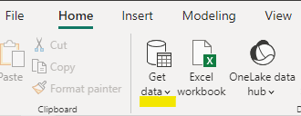

Step 2 –

After connecting the data in Power BI, I start analyzing the data to determine what kind of visual and output I will show from the data, and for those visuals, what kind of DAX I have to make.

Step 3 –

When I am done analysing the data, I make one date table by using the DAX in the Data View section of Power Bi.

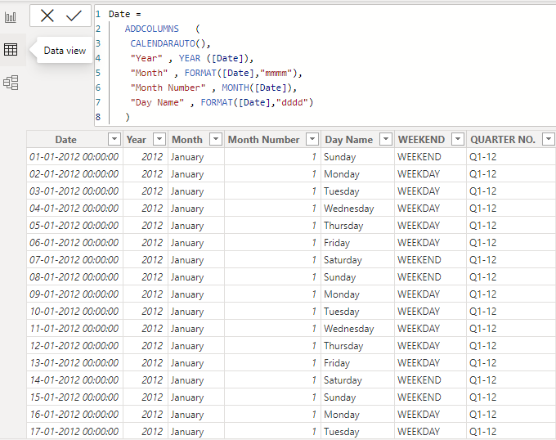

As you can see in the above picture, in this date table I have put Day, Date, Year, Month, and Quarter. This helps me to show the period's sales performance in visualization.

Step 4 –

Then, after completing the date table, I came to the model view section, in which I connected the tables with each other by finding the common column.

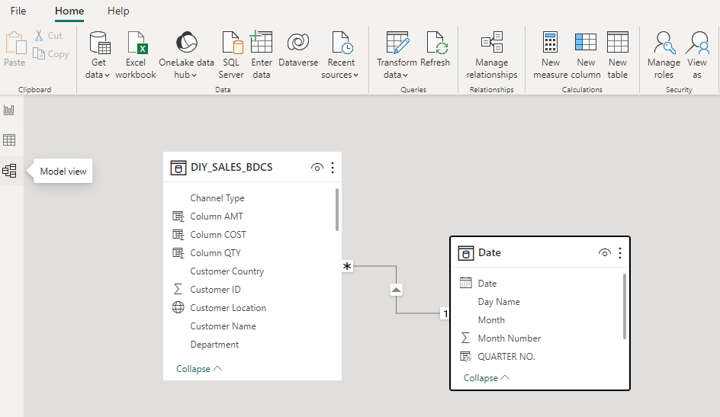

This connecting helps to make the measures in the data view for the separate columns in the data set.

Step 5 –

Completing the modelling part brought me back to the data view for making measurements of the data set. In my report, I have made a total of nine measures for the main columns. Measures are basically used for getting the sum of numeric columns, percentages, etc.

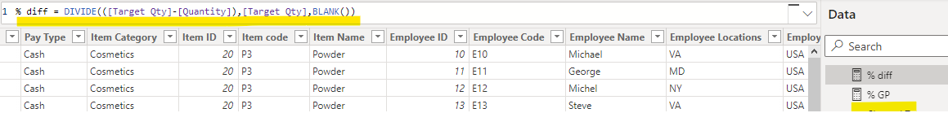

Step 6 –

Visualization

1. **Sales overview –**

This section shows the total sales overview by different categories. Visuals include.

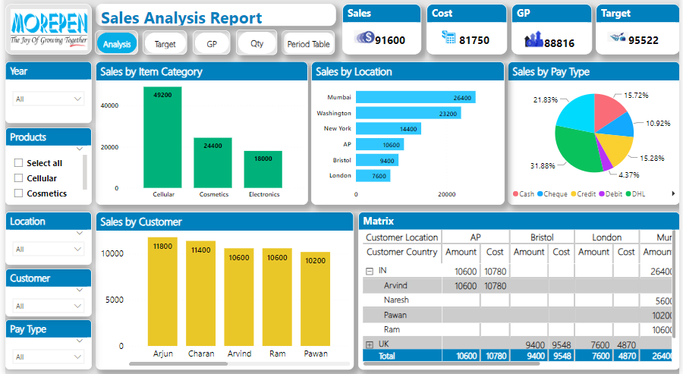

* The first visual in this section is a stacked column chart. This visual shows the total sales of each item category in the business. We can find out which item is the best seller and how much it has sold overall.

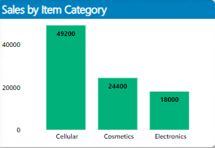

* The second visual is a stacked bar chart, which shows the sales by location or city. We get to know which city sales are higher and which city sales are lower, so that organisation can decide or take steps towards t marketing.

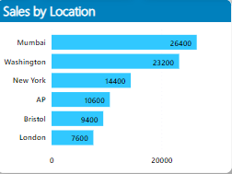

* The third visual is a Pie chart, which displays the sales by payment type and lets us know which mode of payment is most commonly used for payment customers.

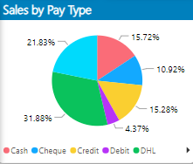

* The fourth visual is a stacked column chart that shows the sales by customers, which means which customers buy the product more and which customers buy it less, so the organisation can target the customers.

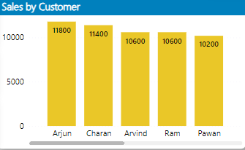

* The last visual is matrix table of all the visuals.

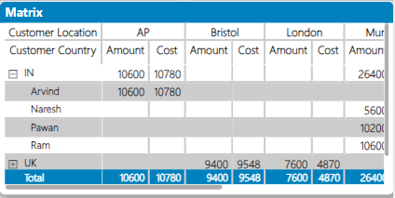

1. **Sales Target vs. Actual Sales -**

This section compares the actual sales with the sales target, emphasising achievement levels. Visuals include,

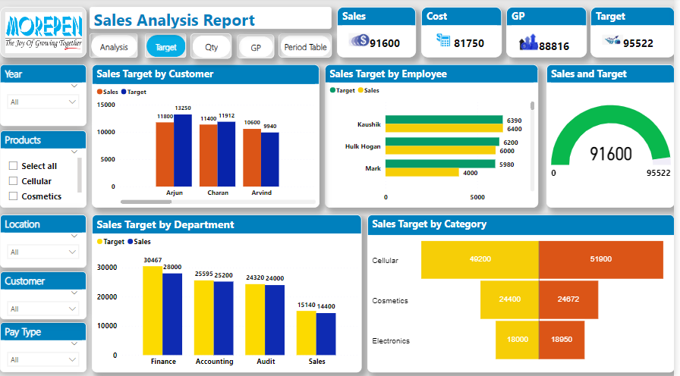

* The first visual is clustered column chart shows that actual sales against target sales by customers mean which customer is fulfilling the sales with target sales.

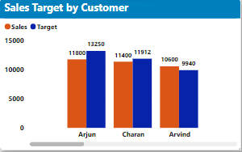

* The second visual is a clustered bar chart that shows actual sales against target sales by employee or salesperson, which means which salesperson is achieving the sales target or how much they are doing as target sales.

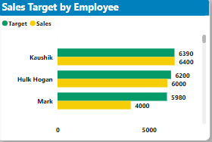

* + The third visual is Gauge chart which display the total sales against the total target sales means this visual explain that is total sales is equal or less from target sales.

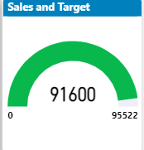

* The fourth visual is a clustered column chart that compares actual sales and target sales by department and shows the total sales as compared to target sales.

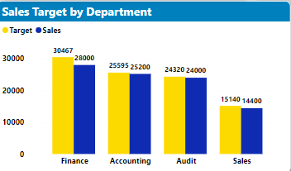

* The fifth visual is Tornado chart which compare the actual sales with target sales by category.

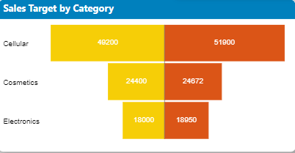

1. **Quantity Target vs. Actual Sales Quantity –**

In this section, the actual sales quantity is compared with the target quantity. Visual include,

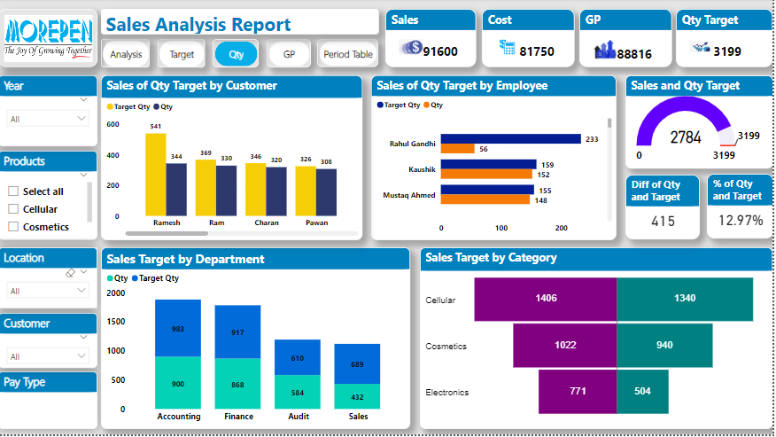

* The first visual is clustered column chart shows that actual sales quantity against quantity target by customers mean which customer is buying the product at how much quantity and customer is how much far from the quantity target or equal to the target.

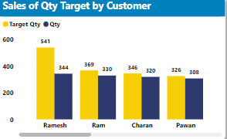

* The second visual is a clustered bar chart that shows actual quantity sales against quantity target by employee or salesperson, which means which salesperson is selling the product at what quantity and what is the target quantity for the salesperson and whether they are achieving it or not.

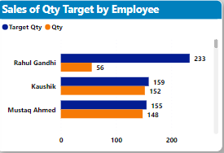

* + The third visual is Gauge chart which display the total sales quantity against the total quantity target means this visual explain that is total sales quantity is equal or less from quantity target. With this I added two cards one card show the difference value of sales quantity and quantity target. The second one shows the percentage of that difference value.

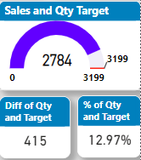

* The fourth visual is the stacked column chart, which compares the actual sales quantity and the quantity target by department and shows the total sales as compared to the target sales.

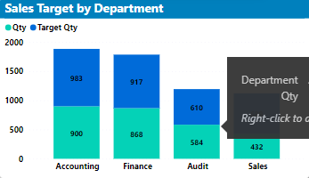

* The fifth visual is Tornado chart which compare the actual sales quantity with quantity target by category.

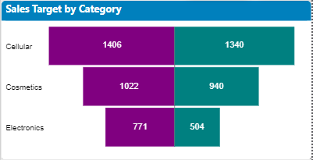

1. **Gross Profit (GP) Analysis** –

This section focuses on the gross profit margin and its comparison to the target. Visual includes,

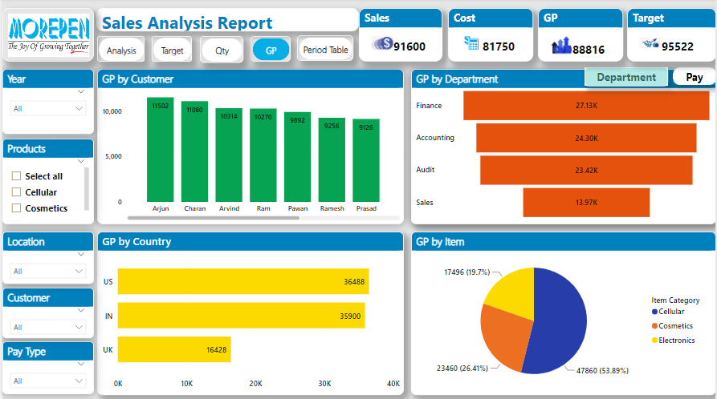

* The first visual is stacked column chart it display the GP margin by customer.

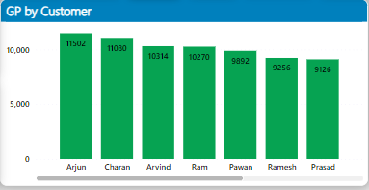

* The second visual is the funnel chart, which shows the GP margin by department. Through this, we also get to know which department has a higher profit.

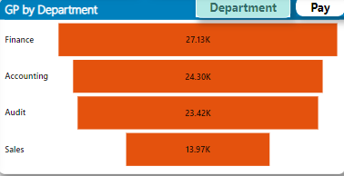

* The third visual is the donut chart, which displays the GP margin by pay type. This visual is just behind the department when using the bookmark tool.

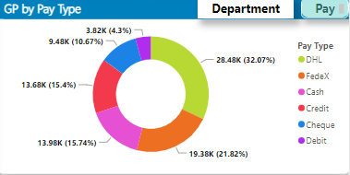

* The fourth visual is a stacked bar chart. This visual shows the GP margin by country; by this, we get to know the highest profit country.

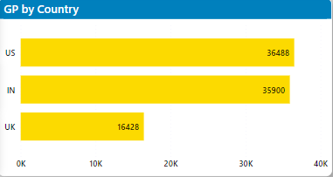

* The fifth visual is pie chart display GP margin by item category.

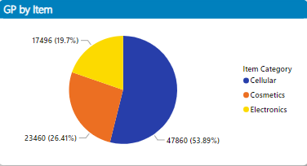

1. **Period Table –**

This section compares the sales performance of different periods. Visuals include,

* Clustered column chart comparing actual sales against the target sales by year, quarter, and month to see the elaborated way sales growth.

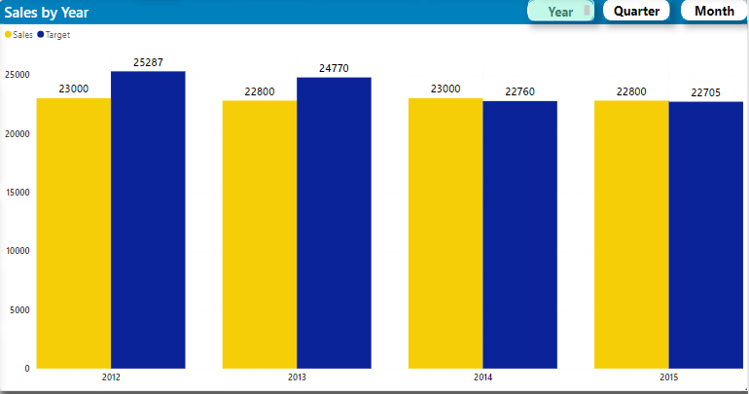

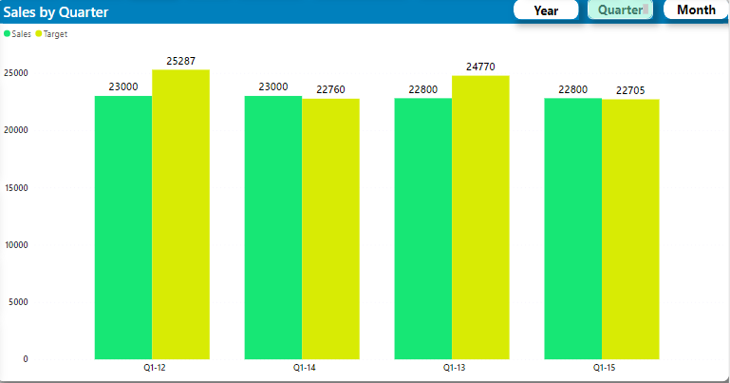

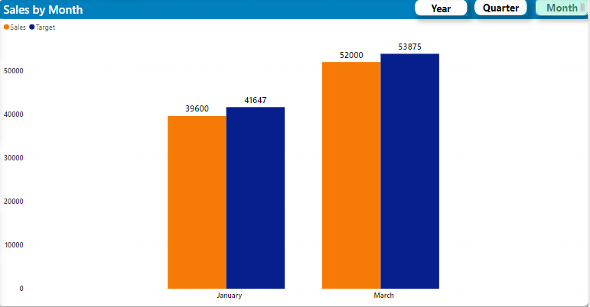

Also, I made detail table pages for sales, targets, and GP. In the sales table, all the details of every visual are listed. In the Target Table, I show both sales target and quantity target details, and as I did in the GP Table, I put all the details related to all the visuals. And connected these tables with the drill-through method with each visual.

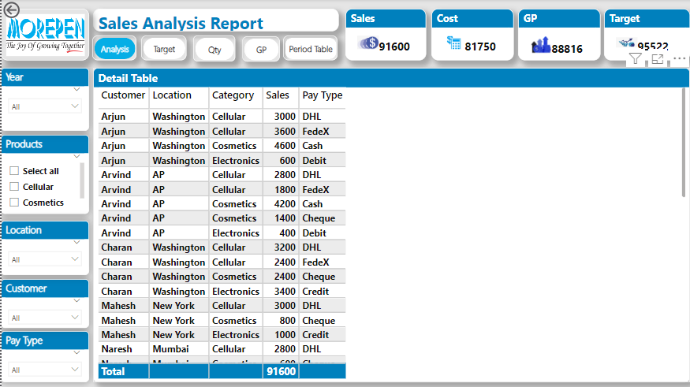 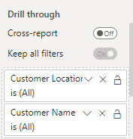

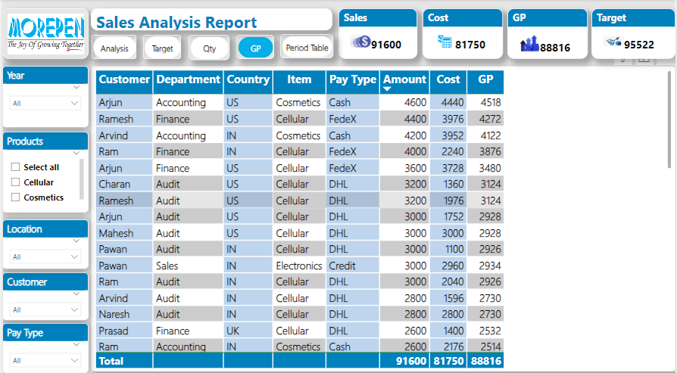 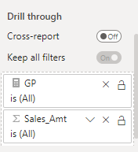

## Health Care report

The main purpose of a health analysis report is to assess and evaluate the overall health and well-being of a particular subject or entity. Health analysis reports are commonly used in various fields, including healthcare, business, and environmental sciences, to name a few. The specific objectives and scope of a health analysis report can vary depending on the context and the subject under consideration. Some of the common purposes of health analysis reports include:

1. **Health Assessment**: The primary purpose of a health analysis report is to provide an assessment of the current health status of the subject being analyzed. This could be an individual patient, a business organization, a manufacturing process, or even a natural ecosystem.
2. **Identification of Issues and Risks**: Health analysis reports aim to identify existing or potential issues, risks, and challenges faced by the subject. By understanding these concerns, appropriate measures can be taken to mitigate risks and address problems.
3. **Performance Evaluation**: In the context of business and organizations, health analysis reports can evaluate the overall performance and efficiency. Key performance indicators (KPIs) are often used to measure the success of operations.
4. **Data-driven Decision Making**: Health analysis reports provide data-driven insights that support decision-making processes. Data visualization and analysis aid in understanding complex information and facilitate informed choices.
5. **Monitoring Progress and Trends**: Health analysis reports are useful for tracking progress over time. They help identify trends and patterns, enabling stakeholders to adjust strategies and plans accordingly.
6. **Comparative Analysis**: Health analysis reports can be used to compare the health of different subjects or entities. For instance, a healthcare provider might compare patient outcomes between different treatment approaches.

Report Detail

I made a report on health analysis in which I have shown all the aspects such as health analysis, patient analysis, repeated patient, and matrix view. By doing this, I have made 4 separate pages in the health report, and each page has different sets of visuals that give a detail related to the health analysis.

The Data set I have used for this report is an Excel file, and in this data I have used data transformation and modelling, DAX, visualisation, and security of the report.

Let's go through each step of the report and get to know its meaning related to health analysis.

Step 1 –

I have import the excel sheet in power bi by Get Data. 

Step 2 –

After connecting the data in Power BI, I start analysing the data to determine what kind of visual and output I will show from the data, and for those visuals, what kind of DAX I have to make.

Step 3 –

When I am done analysing the data, I make one date table by using the DAX in the Data View section of Power Bi.



As you can see in the above picture, in this date table I have put Day, Date, Year, Month, and Quarter. This helps me to show the period's sales performance in visualisation.

Step 4 –

Then, after completing the date table, I came to the model view section, in which I connected the tables with each other by finding the common column.

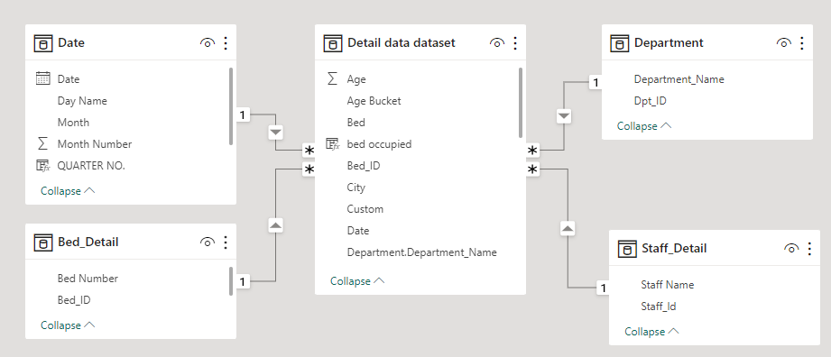

This connecting helps to make the measures in the data view for the separate columns in the data set.

Step 5 –

Completing the modelling part brought me back to the data view for making measurements of the data set. In my report, I have made a total of fifteen measures for the main columns. Measures are basically used for getting the sum of numeric columns, percentages, etc.

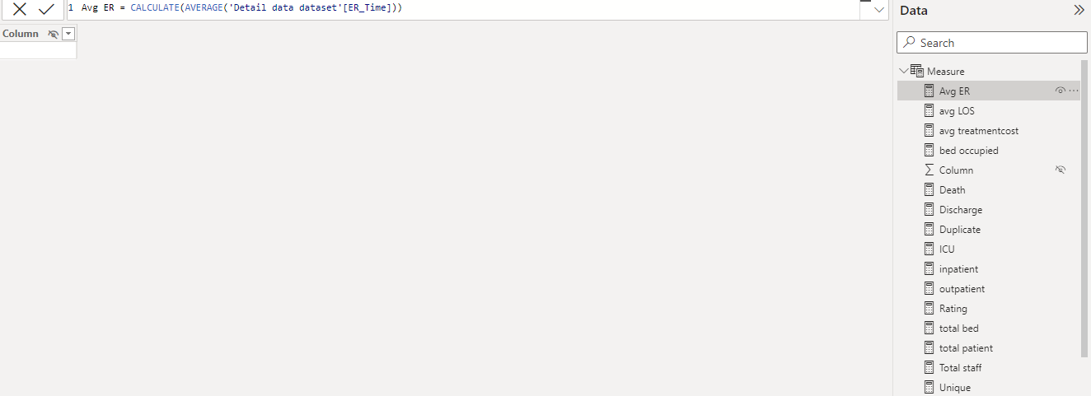

Step 6 –

Visualization

1. **Health Analysis** -This section displays a summary of the hospital review broken down into numerous categories. the visuals include:

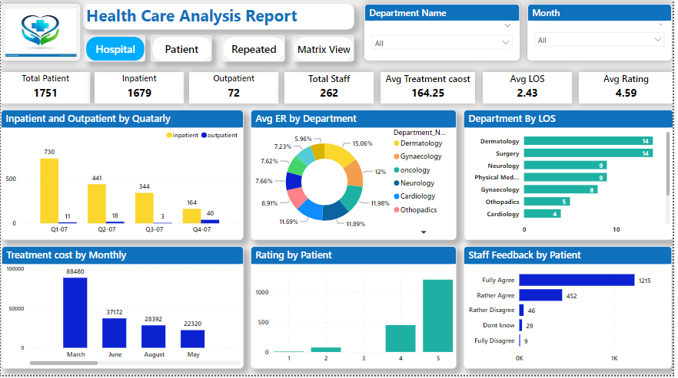

* The first visual is clustered column chart it display the comparison of inpatient and outpatient by quarterly.

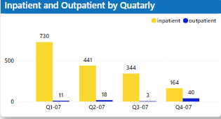

* The second visual is donut chart it shows the Avg. ER by department.

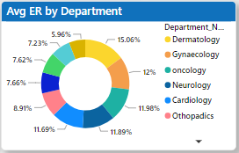

* The third visual is bar chart it display the LOS by department.

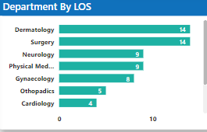

* The fourth visual is stacked column chart in this visual treatment cost by monthly.

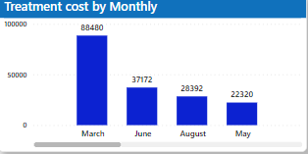

* The fifth visual stacked column chart it display the rating by patient for hospital.

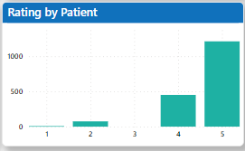

* The sixth visual is stacked bar chart it show the staff feedback of management by patient.

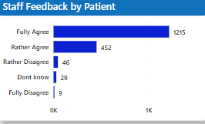

* 1. **Patient Analysis –**

This section shows the patient's details in different categories. Visual includes,

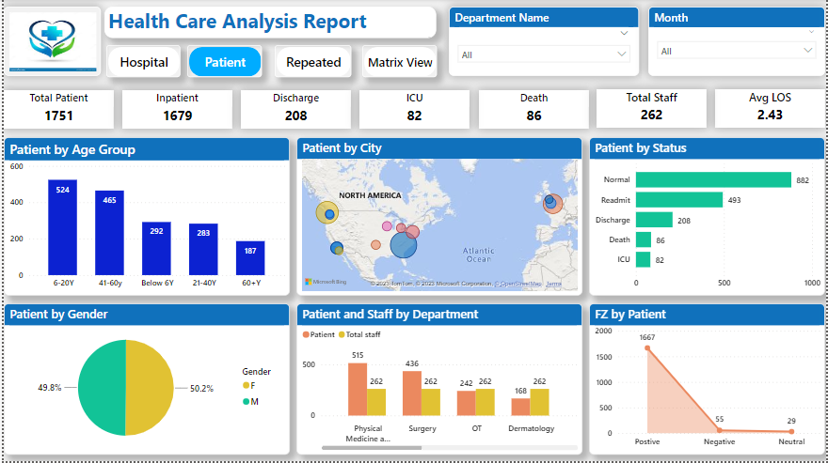

* The first visual is stacked column chart in this visual patient by different age group is shown.

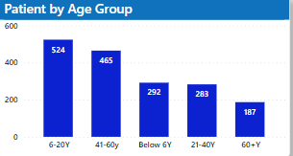

* The second visual is a map in this visual I have shown the patients by cities.

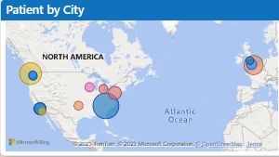

* The third visual is stacked bar chart it shows the patient health status in different category status.

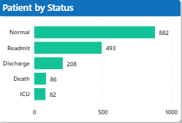

* The fourth visual is pie chart which shows the gender of total patient in hospital in percentage.

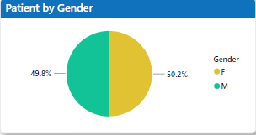

* The fifth visual is clustered column chart in which the total no. of patient and staff by department is shown.

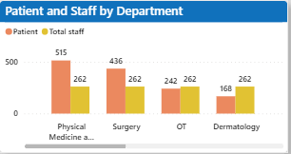

* The last visual is area chart in this visual FZ by patient is shown.

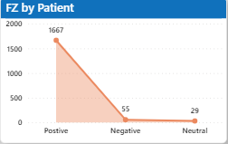

* 1. **Repeated Patient –**

In this section, the repeated patient is shown. Visual include,

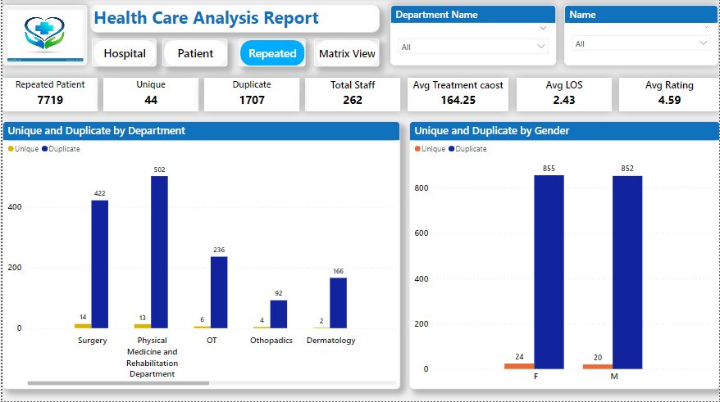

* The first visual is clustered column chart in this I have shown the unique and duplicate patient by department.

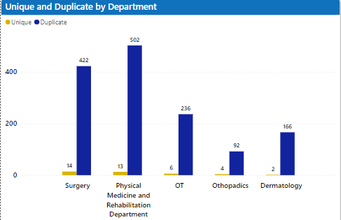

* The second visual is clustered column chart it shows unique and duplicate patient by gender.

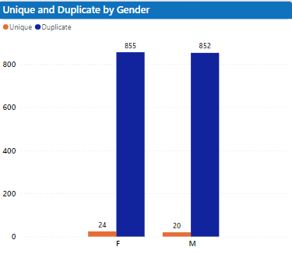

* 1. **Matrix view –**

This section displays the matrix table of the whole report. In this table, I have used department name with status in the row section, age group in the column section, and treatment cost as the value.

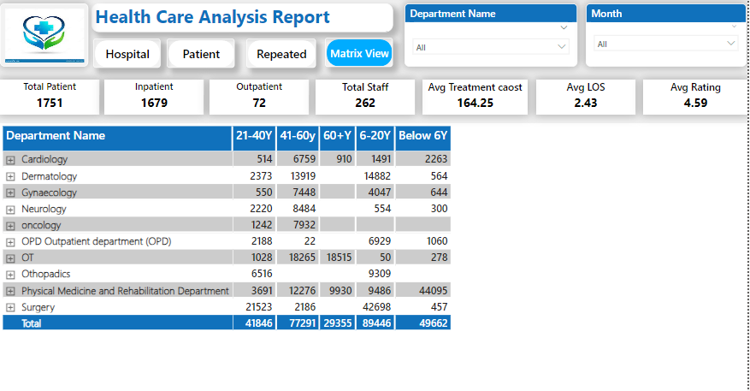In this report, two detail tables are mentioned: one for the hospital analysis and another for patient analysis.

In Hospital analysis detail table all the information of organization is mentioned like patient name, age, gender, city, state, status, department, staff name, treatment cost.

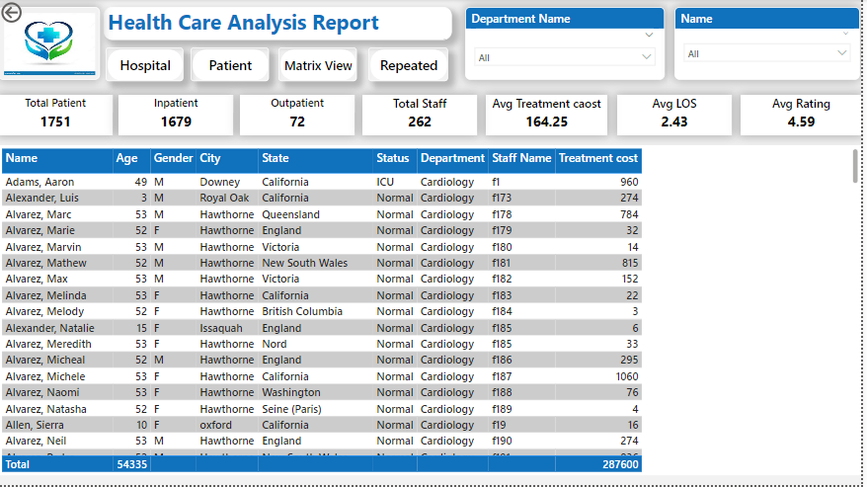

And in patient detail table only patient related information in their like patient name, age gender , department , unique and duplicated patient.

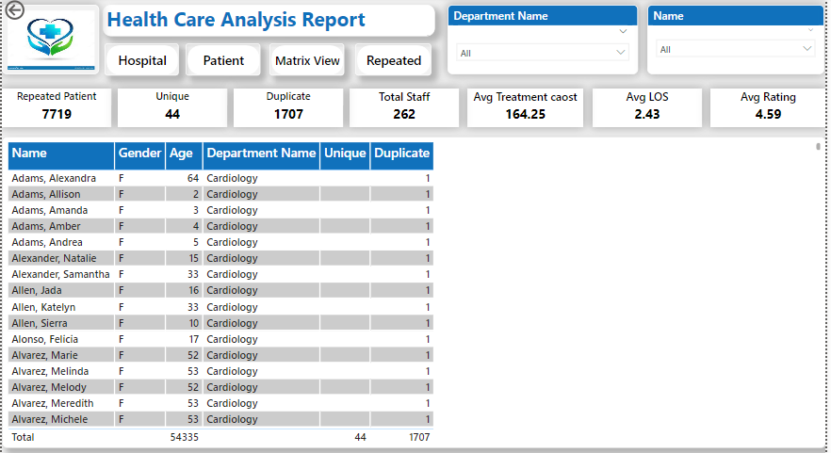

Both the detail table are connect to their respected pages with the drill through method like detail view page is connected with hospital analysis page with each visuals. And DP view is connected with patient analysis page.

**Power BI Service**

It is the cloud based hosting environment for power bi reports. This cloud hosting environment is provide by Microsoft.

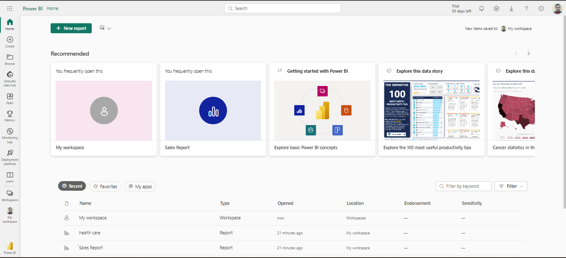

Upper picture is Power BI service portal, there is the concept of workspaces in the Power BI Service.

A workspace is like a shared folder between a team of users. This can be a place to share some of the Power BI content. There are many methods of sharing the Power BI content.

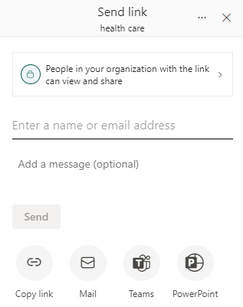

Publish reports to the Service

Reports created in power bi desktop can be easily published to the service. I can even create some objects only in power bi service such as a dashboard as a landing page for multiple reports.

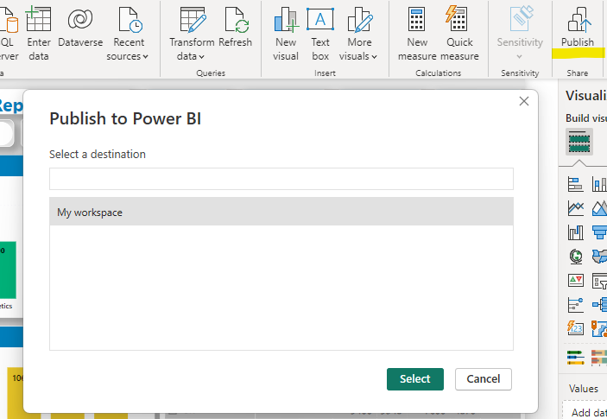

**Workspace**

It is the containers for dashboards, report, workbooks, and datasets in Power BI.

There are two types of workspace

* **My workspace** – It is the personal workspace for any Power BI customer to work with their content. Only I have access to my workspace and if I want to share any content then I have several choices -; create an app workspace where I can bundle content into an app and make it available to others in your organization or create an app workspace and give colleagues access to that workspace so you can share and collaborate.
* **App workspace** – They are used to collaborate and share content with colleagues. They are also the places where you create, publish and mange apps for the organization. Think of them as staging areas and containers for the content that will make up a Power BI app.

**Datasets**

Datasets are a collection of data we will use in power bi. We can import data or establish a connection to cloud data sets over HTTP. Datasets are associated with the workspace. In the workspace, we work on data and a dataset can be part of multiple workspaces,

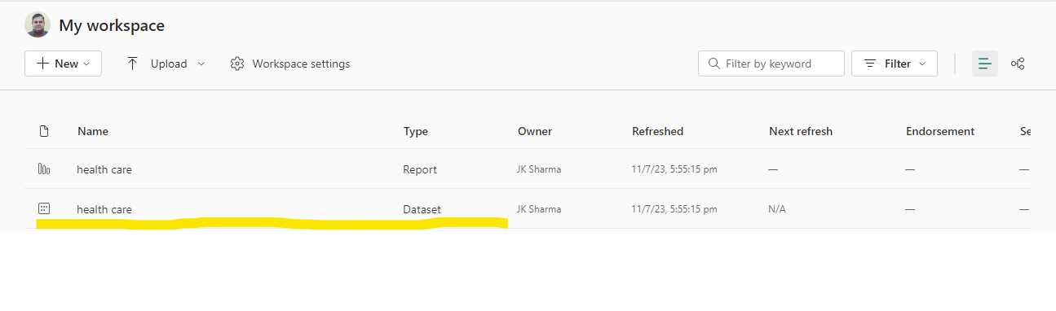

**Reports**

A power bi report is one or more pages of visualization. Visualization are also called visuals. All of the visualizations in a report come from a single dataset. Reports can be created from scratch within power bi can be imported with dashboards that colleagues share with you or can be created when you connect to datasets from excel, power bi desktop, databases.

Reports can be accessed by two methods;

* Editing
* Reading

Only the person who created the report and those granted permission have access to all of the exploring designing building and sharing capabilities of editing view for that report. And the people they share the report with can explore and interact with the report using reading view.

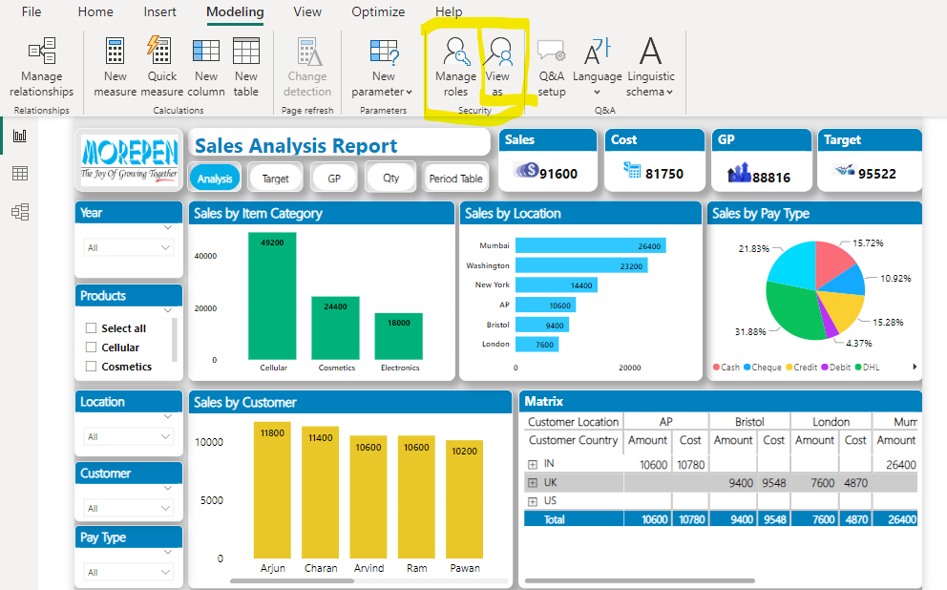

**Dashboard**

A dashboard is something you create in the power bi service or something a colleague creates in the power bi service and shares with you.

* Is associated with a single workspace
* Can display visualization from many different datasets
* Can display visualization from many different reports
* Can display visualization pinned from other tools

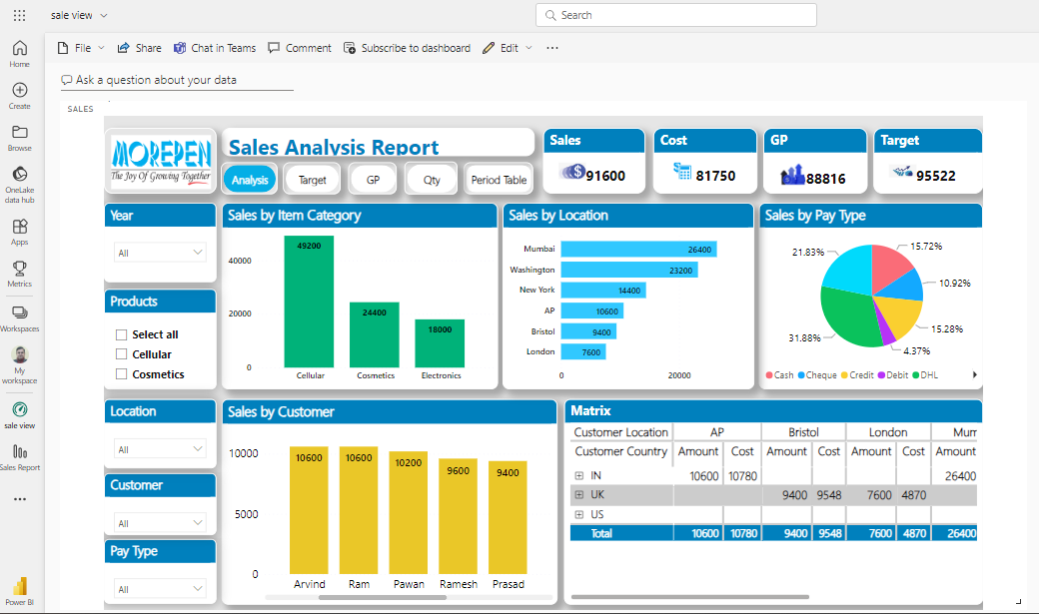

**Role level Security**

It can be used to restrict data access for given user. Filter restrict data access at the row level and you can define filters within roles.

1. In Modelling tab select manage roles

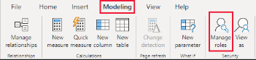

1. Then in Manage Role select create and provide a name for the role.

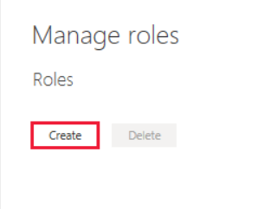

1. Under tables select the table in which I have to apply a DAX. Then in table filter DAX expression box enter the DAX expression.

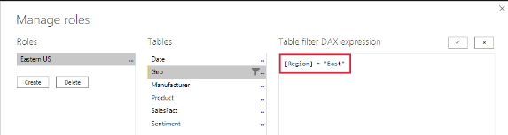

1. After creating the DAX expression select save.

Then click on View As to see the particular role report that was created in Manage Role.

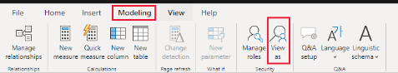

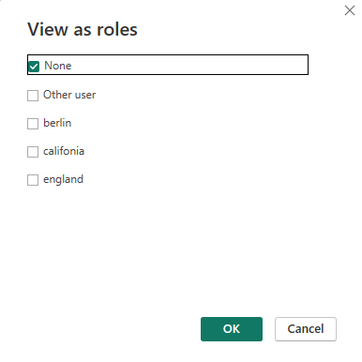

Conclusion

The sales and healthcare reports give a thorough picture of the commercial operations and medical procedures of the corporation. The internship experience gave me useful knowledge about Data Analysis methods and how they can be used in actual situations.

The results of the sales report highlighted how important it is to comprehend consumer behaviour and apply focused strategies in order to maximise sales and profitability. The healthcare study highlighted how critical staff performance, service effectiveness and patient happiness are to delivering high-quality healthcare services.